Development of a Parser for the Next Generation Reliability Information Interchange Format(RIIF.2).

Abstract

Nowadays, computers can be found almost everywhere, usually handing data more quickly, efficiently and with fewer errors. However, there are a lot of things that can go wrong with computer systems (like hardware errors, software bugs, etc.). The failure of critical systems can have even more severe impact on our lives (Banking errors, Emergency errors...). Gradually, reliability is becoming more and more important and is a major concern for many companies. The tools of reliability analysis for silicon designers or computer companies have lagged behind, and reliability has to be tested independent of the design processes. The voices from society for designing and documenting a new standard language for reliability analysis are sharply increasing. Moreover, using a high-level language for reliability analysis enables an enormous improvement in the design of fault tolerant systems. The language RIIF (Reliability Information Interchanges Format) has been proposed, which can expresses the failure mechanisms related to a generic component. Complex components can be constructed from several single components. However, RIIF was only providing a limited scalability and had problems with multiplexing. As a consequence, a new language named RIIF-2 has been published recently, which extends RIIF language and performs a OO-like hierarchical structure, providing a high flexibility and scalability. The goal of RIIF-2 language is to detect and manage the unreliability from technology levels up to software levels. RIIF-2 language has also operated some new properties and new component structures that will help and improve the design to simulate a full computer system.

In order to guide and format users to develop RIIF-2 language, the need of a parser of the RIIF-2 language has risen. In this thesis report, a new designed parser for Reliability Information Interchange Format (RIIF-2) had been developed, which provides users the functionalities of syntax checking and error mentioning and library generation. The language ANTLR.4 (ANother Tool for Language Recognition) is a powerful parser language that used for reading, processing, executing, and translating structured texts or binary files. From a formal language description called grammar, ANTLR generates a parser for that language that can automatically build parse trees, which are data structures representing how a grammar marches the inputs. ANTLR also automatically generates tree walkers that be used to visit the nodes of parse trees to execute application-specific code. ANTLR can generate parsers in JAVA, C#, GO, JavaScript and many others computer languages. In personal case, the designed parser would be implemented in JAVA, and the output data would be stored in MySQL database.

Chapter 1

Introduction

Chapter 2 aims at introducing the RIIF language and getting a general overview of RIIF-2 language and have an introduction of RIIF-2's capabilities.

ANTLR v4 is a new version of ANTLR and has a huge different structure compared to previous edition of ANTLR. ANTLR v4 is a powerful parser generator that you can use to read, process, execute, or translate structured text or binary files. It’s widely used in academia and industry to build all sorts of languages, tools, and frameworks. From a formal language description so called grammar, ANTLR generate a parser for that language that can automatically build parse trees, which are data structures representing how a grammar matches the input. ANTLR also automatically generates tree walkers that you can use to visit the nodes of those trees to execute application-specific code.

The v4 release of ANTLR has some important new capabilities that reduce the learning curve and make developing grammars and language applications much easier. The most important new feature is that ANTLR v4 gladly accepts every grammar you give it (with one exception regarding indirect left recursion, described shortly). There are no grammar conflict or ambiguity warnings as ANTLR translates your grammar to executable, human-readable parsing code.

Chapter 2 The RIIF/RIIF-2 language

2.1 Introduction to RIIF

Reliability is an attribute of any computer-related component (software, hardware for example) that consistently performs according to its specifications. These days, the importance of reliability of computer systems has been considered as a really crucial issue. Over the years, EDA tools have been developed to handle the design, verification and implementation challenges of large and complex systems. However, the tools for reliability targets are absent, which makes the reliability non joinder.

The determination of fault tolerant could not be achieved simply by summing up the error rates of the underlying components, because several strategies like error correction and redundancy can reduce the overall error rate. In this case, a tool for reliability analyzing has become an importance and essential.

Using a language for reliability analysis by automating tasks which are currently performed manually, often using cumbersome spreadsheets, brings a major productivity improvement in the design of fault tolerant systems. A machine-readable format ensures tighter integration of reliability analysis with the existing silicon design flow. A language for reliability analysis, combined with an ecosystem of related EDA tools, is a key enabler to exploit future process technologies, which are becoming intrinsically less reliable.

Accurately modeling the reliability of a complex system starting from the failure rates of cells and low-level components is challenging and requires a hierarchical methodology. The nature of failure modes varies with the level within the system hierarchy. At the system level, the end-user is affected by events such as server outages, system reboots because of lost packets or silent data corruption. At the chip-level, typical failure modes are the occurrence of parity error, uncorrectable ECC errors or interrupts. At the cell or technology level, typical failure modes are single bit upsets, word-line failures, etc. A hierarchical approach is needed to capture how failures propagate and to optimize migration schemes across different levels.

The RIIF language is a high-level hardware description language associated with a generic component, which offers the silicon designer and developers the possibility to bound the reliability testing processes up with silicon designing processes. The language is also providing a standard format for component suppliers and computer design companies. Starting from a simple component, the users would build full computer hardware pictures by this language, where the propagation of the failures from lower to higher levels can be expressed.

RIIF language is composed of four modules which are component, environment, requirement and bind. The modular component in RIIF can represent a simple real component in computer system like a hard drive or a block of RAM and can also express a complex real component like a CPU board. The modular requirement in RIIF encapsulates a set of requirements that used to restrict components' variables systematically. To avoid replicating information in every model that was created, the modular environment structure is used to encapsulate a set of parameters in a re-usable container. The last modular bind can indicate a bounding relationship between a requirement and a component.

In RIIF, the keyword component is used to model a system component representing the main RIIF entity. A component could include children components which are components and has already been defined in RIIF language. Besides, a component can consists of variables, parameters, constants and fail_modes. Each of them, when they were created, has several default attributes attached to. The form of those attributes is available in the appendix.

Since the declaration form of variables parameter and constant is the same, the only different is parameters can be modified on demand, while constants can not be modified once it had been assigned with a valid value. According to the language reference, variables parameter and constant differs on semantic meaning instead of grammar. In order to remove the redundancy of codes, variables parameter and constant are rubbed up into fieldDeclaration in the RIIF grammar that will be introduced in chapter 4.

Parameters are the most basic variable in RIIF language, and can be assigned with type integer, float, string, boolean, or enumeration. Constants have the same types and meaning with parameters, but can not be changed once it has been assigned with a valid value. Fail mode is another essential part in RIIF language, which represents the fail modes that could happen in a component. Fail mode has several attributes attached, when the fail mode was created through the key word FAIL_MODE. One of those attributes named RATE indicates the reliability rate for the fail mode.

There is another important keyword called ASSIGN, which is used for assigning values to variables and for propagating values in to child components.

In order to achieve modularity for generic components at the system-level, it is important to ensure that the models are consistent in how they specify failure modes. All SRAM suppliers must specify the same set of failure modes with the same units. This is achieved through a template. A template is simply a partial declaration of a component. In the template declaration, the failure modes are declared. In a separate file, the template is extended to produce an actual component declaration which elaborates the rates of each failure mode. In practice, components can extend a template thorough the keyword EXTENDS, which makes the component can inherit all the variables that has defined in the template.

There are still some limitations in RIIF language. For example, the definition of a template is based on the definition of hardware component, which constrains the template to be a component. It is effective for small libraries components, while it is inefficient for large, complex libraries.

2.2 Introduction to RIIF-2

In order to simplify the hardware description in RIIF language and provide a more efficient way for large complex computer systems, the language RIIF-2 has been proposed. The RIIF-2 language extends the RIIF language and equips with more mature and modern hierarchical mechanisms. In addition, RIIF-2 language also considers that the software part is a primary portion of a computer system. In fact, errors occur in hardware which could be addressed in software is quite normal. RIIF-2 language considers that the software is a necessary part of digital systems and that software commonly has abilities in handling hardware errors. Raw errors are generated at the technology level due to undesired effects, since every item of property has its own lifespan such as aging, environmental stress, variability etc. Moreover, many detectable errors can be gracefully managed by correcting software routines executed in a complex system. The routines play significant roles in introducing this type of masking effects and must be properly characterized when implementing cross-layer reliability solutions to potentially reduce the design margins imposed at the hardware level. As a result, RIIF-2 language comes up with the concept of propagating faults from chip-level to software-level. RIIF-2 language provides a brand-new field which can be declared through the keyword Platform. Typically, platform is declared in a software template in RIIF2, specifying which hardware this software template executed on. In this way, we can consider entire system stack in reliability analysis.

RIIF-2 language introduces a new template statement, which is a specific component and has to be implemented by components. In template, everything is abstract and simply identified by a label name. Within a template, predefined values for parameters or constants can be assigned either in-line or through the new introduced keyword impose. The predefined value can be inherited by other templates or implemented by other components. Undefined values can be defined through the use of the abstract keyword. Abstract parameters identify mandatory information which must be defined in all components implementing the template. Once a template is applied to a component, the user is required to define the actual values for all abstract items described within the template. The application of a template to a component is described through the new keyword implements.

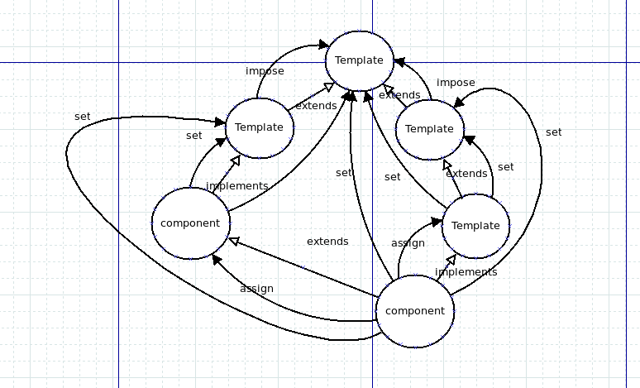

Figure 2.1

Figure 1 reveals a full picture of the definitions of hierarchical structure in RIIF-2 language. The white arrows indicate inheritance, while the black arrows stand for assignments. The hierarchical relation is a JAVA-like structure. With an additional feature which allows an object inherits multiple objects, it then gains some more flexible and more complicated capabilities.

In RIIF-2 language, components or templates can be derived from other components or templates, thereby inheriting fields from other components/templates. A template can be extended by other templates and implemented by other components. When a complex hierarchy of computer components must be described, multiple templates can be implemented by the same components, thus allowing complex usages. The elements inside a template can be assignment with values not only in the template itself, in a template that extends the template using the keyword Impost, but also in a component that implements the template using the keyword Set. A component can be extended with some new fields added. The extended component fields can be assigned by keyword Assign. The expression power of inheritance mechanism is further increased when coupled with the introduction of inheritance in RIIF language. The capability of an extension looks like expanding a component in RIIF. When it comes to RIIF-2, an template can extend other templates, which makes the template like a “super-template”. Through inheritance, both templates and components can be redefined, thus creating new templates or components which inherit all the definitions contained in their parents and modify only those portions that differ. Together with the inheritance mechanisms, a new keyword SELF has been introduced in RIIF-2. The use of the keyword SELF comes from inherited templates/components and provides the children templates/components with the possibility to get values from parent templates/components. In practice the keyword is normally used in a table data structure.

The idea of inheritance is simple but powerful and it completely tight the readability test process with silicon design process. For example: when a silicon designer wants to create another silicon unit and combine it with other silicon units or when a computer companies bought components from suppliers and combined them to a board. N.B. extended components/templates can not propagate values into their child or children.

The example of associative array in RIIF-2 language is shown in figure 2. The keyword Abstract before an element reveals that the declared elements inside the template is a metaphysical element and has to be concreted in components that extends this template. Abstract fields identify mandatory information that must be defined in all components implementing the template. Once a template is applied to a component, the user is required to define the actual values for all abstract items described within the template. Line 10~12 in the figure 2 indicates that two associative arrays are created. Before using an associative array, we have to fill it. The line 14~23 indicates how we can initialize and manage an instance in an associative array. Since instances within an associative array are created on demand, it can be achieved either through a declaration of an instantiation in an associative type or through an assignment statement (like Impose in template). The corresponding instance will be automatically created in the associative array. Specifically, when the instance of array has not been created yet, a new instance will be created simultaneously. The predefined value in a template can be modified by an extending template through keyword Impose.

template SRAM_TEMPLATE;

// All SRAMs must defined voltage, temperature and size
abstract constant NAME : string;
abstract constant MANUFATURER : string;
abstract parameter CORE_VOLTAGE : float;
abstract parameter NUM_BITS : integer;

// All SRAMs must have radiation induced failure modes
abstract fail_mode RAD_FM[];
// All SRAMs must have permanent failure modes
abstract fail_mode PER_FM[];

abstract fail_mode RAD_FM[SBU]'RATE;
impose RAD_FM[SBU]'UNIT = FITS;
abstract fail_mode RAD_FM[MBU]'RATE;
impose RAD_FM[MBU]'UNIT = FITS;
abstract fail_mode RAD_FM[SEFI]'RATE;
impose RAD_FM[SEFI]'UNIT = FITS;
abstract fail_mode RAD_FM[SEFI]'RATE;
impose RAD_FM[SEFI]'UNIT = FITS;
abstract fail_mode RAD_FM[SSAF]'RATE;
impose RAD_FM[SSAF]'UNIT = FITS;

endtemplate

Figure 2

Figure 3 is an example which contains a template named FLIP_CHIP_TEMPLATE, a template name SYMSRAM and a component CY7C1263XV18 which implements both templates FLIP_CHIP and SYNCSRAM. In this case, the component has to initiate abstract fields in both templates through the keyword SET. Using fully qualified name is allowed in this language. Taking the lines 32~33 in figure 3 as an example, the NAME file has declared in both template FLIP_CHIP and template SRAM. Therefore, we can access NAME field by specifying a template name as prefix, followed by a dot and then followed by the filed name.
template FLIP_CHIP_TEMPLATE;

//all flip chip packages must contain the following info
abstract constant NAME:string;
abstract parameter NUM_BUMPS :integer;
abstract parameter PACKAGE_TEMP: float;
impose PACKAGE_TEMP'UNIT = CELSIUS;

//all flip-chip package have these failure mechanisms
abstract fail_mode OPEN_BUMP;
abstract fail_mode DIE_CRACK;
endtemplate

template SYNCSRAM_TEMPLATE extends SRAM_TEMPLATE;

abstract parameter CLK_Speed : integer;
impose CLK_Speed'unit = MHZ ;

endtemplate

component CY7C1263XC18 implements
SYNCSRAM_TEMPLATE,FLIP_CHIP_TEMPLATE;

set MANUFACTURE = "CYPRESS";
set CORE_VOLTAGE = 1.8;
set NUM_BITS = 37748736;
set CLK_Speed = 633;
set NUM_BUMPS = 165;
set PACKAGE_TEMP'MIN = 0;
set PACKAGE_TEMP'MAX = 70;
set RAD_FM[SBU]'RATE = 0;
set SYNCSRAM_TEMPLATE.NAME = "CY/C1263XC18";
set FLIP_CHIP_TEMPLATE.NAME = "165-LBGA";

endcomponent

Figure 3

Array is a basic data structure that has defined in the related references. According to the definition in RIIF specification, an array is a sequence memory that stores one or more same type of values in a single value field. Before using an Array structure, the code writer has to declare the size of the array, which is not elegant when the size can not be known in advance. For this reason, RIIF-2 language introduces a new associative array. The associative array is similar to array in terms of structure but they are different in terms of their index. Associative array will have its indexes as strings so that you can establish a strong association between the keys and the values. Furthermore, associative array enables code-writers to declare it without specifying its size statically. Instead, an instance of associative array is instantiated on demand. From this point of view, array is a static data structure while associative array is a dynamic data structure. an empty brackets are used to denote the associative arrays and indicate that the number of elements is undefined and new elements can be freely appended to the array. In figure 2, there is an example for declaring and operating an associative array data structure.

One of the new complex data structures introduced in RIIF-2 language is the table. Table is a grid structure and can be established through the keyword TABLE. Table field are accompanied with two attributes HEADER and ITEMS. HEADER attribute is a list of strings and ITEMS attribute is a JSON-like data structure, and the table values are stored into the attribute ITEMS. The number of table columns depends on the number of items in the header. In addition to table data structure, a new operator symbol [#] is described. Sharp operation allows iteratively accessing and operating the same column field in one table.

The example of a template modular in RIIF-2 language is shown in figure 2. The keyword Abstract before an element reveals that the declared elements inside the template is a metaphysical element and has to be concreted in components that extends this template. Abstract fields identify mandatory information that must be defined in all components implementing the template. Once a template is applied to a component, the user is required to define the actual values for all abstract items described within the template. Line 10~12 in the figure 2 indicates that two associative arrays are created. Before using an associative array, we have to fill it. The line 14~23 indicates how we can initialize and manage an instance in an associative array. Since instances within an associative array are created on demand, it can be achieved either through a declaration of an instantiation in an associative type or through a assignment statement (like Impose in template). The corresponding instance will be automatically created in the associative array. Specifically, when the instance of array has not been created yet, a new instance will be created simultaneously. The predefined value in a template can be modified by an extending template through keyword Impose.

Line 8 ~ 13 in figure 4 gives an example on how to create a table in RIIF-2 language. Line 8 declares a table structure as a parameter, Line 9 declares the table's header and the declaration of header is same with a declaration of a list. The definition of header is also defining the definition of columns for a table. In this case, we would have three columns with label name [FAILMODE, SFM, RATE]. In the line 10~13, two rows are inserted into the table and each row consists of three column. Pay attention, each column should has same type, because table structure would allow sharp operation, which will iteratively accesses same column in each row and performs same operation for those field.
component VECTORCALC_CORE;
// An hardware component performing vectorial calculations

//parameter fail_mode SBU;
fail_mode SBU;
assign SBU'RATE = 10; //obtained from radiation tests

parameter SW_FM: table;
assign SW_FM'HEADERS = {FAILMODE,SFM,RATE};
assign SW_FM'ITEMS = { //obtained from fault injection
["SUB", "WRONG_DATA", 0.3*SBU'RATE],
["SBU", "WRONG_INSTRUCTION",0.2*SBU'RATE]
} ;

endcomponent

Fig. 4

Figure 4

Since the RIIF-2 language aims at simulating a full computer system stack and considering software as an essential portion in a computer system, the ability of constructing software should be pretty straightforward. A good behavior is to build a template which used for representing software. By declaring the variable platform inside the template, we can simply establishing a link between hardware to the software through a setting operation from a hardware layer. Figure 5 is an example indicating how to declare a software template in RIIF-2 language and how to use platform in the software template.

template SW_COMPONENT;
//all programs must define the name,size...

abstract parameter NAME:string;
abstract parameter SIZE:integer;
abstract parameter LOOPS: integer;
abstract parameter PROTECTION: enum {NONE, VAR_DUP};
abstract parameter READ_ACCESS: integer;
abstract parameter WRITE_ACCESS: integer;
abstract platform execute_on;

//List of possible SFB considered in our library
abstract constant SFB_ITEMS : integer := 1000000;
abstract constant SFB_LIST := {
INT_TIME, UNDETECTABLE,
EARLY, LATE, FULL_UNRESPONSIVE, PARTIAL_UNRESPONSIVE,
RESPONSIVE, DATA_BENIGN, NO_DATA, EDC, NON_EDC };

// Timing constraints depending on the workload
abstract parameter TIMING_CONSTRAINTS : table;
impose TIMING_CONSTRAINTS'HEADERS = {
WORKLOAD, EXEC_TIME, MAX_TIME, AVG_TIME};

abstract parameter SFB : table;
impose SFB'HEADERs = { SFM_TYPE,SFM,OCCURING_SFB,
OCCURRING_SFB_RATE};
endtemplate

Figure 5

Figure 6 shows has to execute a hardware component in the software template, shows the usage of SELF and the usage of SHARP operation in the TIMING_CONSTRAIN table.

component VADD implements SW_COMPONENT;
set NAME = "Vector ADD";
set SIZE = 524;
set PROTECTION = NONE;
constant NUMBER_OF_ITEMS :integer:= 10000;
set READ_ACCESS = 76*NUMBER_OF_ITEMS / 10000;
set WRITE_ACCESS = 75*NUMBER_OF_ITEMS / 10000;
set LOOPS = 3;
child_component cpu VPRINT ;

set execute_on = VECTORCALC_CORE;

set TIMING_CONSTRAINTS'ITEMS = {
["TEST_BENCH1",0.0000001,2, 0.000001],
["TEST_BENCH2",0.0000003,2.1, 0.0000004] };

set SFB'ITEMS = {
[ "permanent", "WRONG_DATA", SFB_ITEMS, {0.893, 0.107, 0, 0, 0.891, 0.042, 0.067, 0.413, 0.109,0.052,0.426 } ],
[ "permanent", "WRONG_DATA", SFB_ITEMS, {0.893, 0.107, 0, 0, 0.891, 0.042, 0.067, 0.413, 0.109,0.052,0.426 } ]
};

endcomponent

component VADD_VARIABLE_DUPLICATION_VER1 extends VADD;
set NAME = "vector ADD_with_Variable_Duplication";
set PROTECTION = VAR_DUP;
set TIMING_CONSTRAINTS'ITEMS = { (PROTECTION != VAR_DUP)
? ["TEST_BENCH1",self+0.001,self+0.9,self+0.0015]
: ["TEST_BENCH1",self,self,self ],
(PROTECTION != VAR_DUP)
? ["TEST_BENCH3",self+0.001,self+0.2,self+100]
: ["TEST_BENCH3",self,self,self+10000 ]
};
endcomponent

component VADD_VARIABLE_DUPLICATION_VER2
extends VADD_VARIABLE_DUPLICATION_VER1;

set TIMING_CONSTRAINTS'ITEMS[#][EXEC_TIME]=
(PROTECTION == VAR_DUP)? self + 0.001 :self ;
set TIMING_CONSTRAINTS'ITEMS[#][MAX_TIME]=
(PROTECTION == VAR_DUP)? self+0.2 : self;
set TIMING_CONSTRAINTS'ITEMS[#][AVG_TIME]=
(PROTECTION == VAR_DUP)? self + 0.0015 : self ;

endcomponent

Figure 6

Chapter 3. Introduction to ANTLR.4

ANTLR.v4 is a powerful parser language that you can use to generate a specific language parser according to the grammar of the language that you have given. Basically, the main job of a language parser is to recognize inputs and response in some way. For achieving that goal, ANTLR.v4 provides a SAX-like approach to enable users to visit each grammar rule and to process the corresponding inputs. According to language reference, ANTLR.v4 can recognize a language's pattern and can automatically generate a parse tree for it, using a visitor to visit each nodes inside the parse tree and calling the listener method in that node from the visitor.

In this chapter, the important ideas of ANTLR.v4 will be introduced, especially for the Visitor/Listener mechanism. Besides, this chapter will describes some basic syntax rules and advanced properties that have been adopted in ANTLR.v4. As we go along, some examples taken from the RIIF-2 parser will be shown to help readers to understand the language ANTLR.v4.

In addition, this chapter would introduce readers how to use ANTLR.v4 to build data readers, language interpreters and translators. This chapter will helps readers to get a general overview of ANTLR.v4 's capabilities and to explore language application architecture.

3.1 The Big Picture

This section will introduce the outline of ANTLR.v4 and give readers the big picture about the language's structure. A simple example can be found in this section to display the working principles in ANTLR.v4.

To understand a human-language, we can take an English thesis as an example. Readers have to recognize all of the valid sentences, phrases, and sub-phrases of the English language thesis. We do not read a sentence character by character. Instead, we perceive a sentence as a stream of words. The human brain subconsciously groups character sequences into words and looks them up in a dictionary before recognizing grammatical structure. Recognizing a phrase means we can identify the various components and can differentiate it from other phrases. It is totally the same when it comes to a computer language parser. We can replace the English thesis to a structured computer language text and replace human brain to a designed language parser. To recognize and react to inputs appropriately, a parser has to store every “word” from the inputs language and try to form a grammatical sentence. Taking the assignment statement in RIIF language as an example, we want to recognize the input: “ assign SBU'RATE = 10; ”. That means we know that SBU'RATE is the assignment target and 10 is the value to store. Recognizing assignment “assign SBU'RATE = 10;” also means that the language application sees it as clearly distinct from, say, an import statement. After recognition, the application would then performs a suitable operation such as performs “Assignment("SBU'RATE", 10)” or “translateAssignment("SBU'RATE", 10)” .

Programs that recognize languages are called parsers or syntax analyzers and syntax refers to the rules governing language membership. Normally, a grammar is just a set of rules that used to represent syntax of languages, each one expressing the structure of a phrase. The ANTLR tool translates grammars to parsers that look remarkably similar to what an experienced programmer might build by hand. Actually, ANTLR is a program that writes other programs. Grammars themselves follow the syntax of a language optimized for specifying other languages: ANTLR’s meta-language.

Parsing is much easier if we break it down into two similar but distinct tasks or stages. The process of grouping characters into words or symbols is called lexical analysis or simply tokenizer. Call a program that tokenizes the input a lexer. The lexer can group related tokens into token classes or token types, such as INT (integers), ID (identifiers), FLOAT (floating-point numbers). The lexer groups vocabulary symbols into types when the parser cares only about the type, not the individual symbols. Tokens consist of at least two pieces of information: the token type (identifying the lexical structure) and the text matched for that token by the lexer.

The second stage is the actual parser and feeds off of these tokens to recognize the sentence structure, in this case an assignment statement. By default, ANTLR-generated parser builds a data structure called a parse tree or syntax tree that records how the parser recognized the structure of the input sentence and its component phrases.

The following diagram illustrates the basic data flow of a language recognizer:

start
Assignment
assign
SBU
' RATE
=
10
;
expression
Input:
Assign SBU'RATE = 10 ;
Lexer
Assign
SBU'RATE
=
10
;
Parser

Figure 3.1 language recognizer

The interior nodes of the parse tree are phrase names that group and identify their children. The root node is the most abstract phrase name. The leaves of a parse tree are always the input tokens. Sentences, linear sequences of symbols, are really just serializations of parse trees we humans grok natively in hardware. To get an idea across to someone, we have to conjure up the same parse tree in their heads using a word stream.

By producing a parse tree, a parser delivers a handy data structure to the rest of the application that contains complete information about how the parser grouped the symbols into phrases. Trees are easy to process in subsequent steps and are well understood by programmers. Better yet, the parser can generate parse trees automatically. By operating off parse trees, multiple applications that need to recognize the same language can reuse a single parser. The other choice is to embed application-specific code snippets directly into the grammar, which is what parser generators have done traditionally.

The ANTLR tool generates recursive-descent parsers from grammar rules. Recursive-descent parsers are really just a collection of recursive methods, one per rule. The descent term refers to the fact that parsing begins at the root of a parse tree and proceeds toward the leaves (tokens). The rule we invoke first, the start symbol, becomes the root of the parse tree. That would mean calling method start() for the parse tree in the previous section. A more general term for this kind of parsing is top-down parsing; recursive-descent parsers are just one kind of top-down parser implementation.

3.2 Parser Tree

It is time to start by looking more closely at the parse tree data structures and those classes that used for recognition and for parse trees. In this section, a passing familiarity with the data structures will make future discussions more concrete.

As it has been introduced above, ANTLR.v4 can build a parse tree automatically following the grammar that you have given and the inputs. In order to make a interactive actions between users and the parser trees, ANTLR.v4 has to execute some appropriate codes for each input phrase or sub-phrase. The nice thing about operating on the tree is that we’re back in familiar Java territory.

According to the introduction above, ANTLR.v4 is made of two parts: a lexer , the tokenizer, and a parser, the syntax analyzer. A lexer is in charge of processing characters, recognizing the tokens and passing tokens into the parser, which in turn checks syntax and create a parse tree. The corresponding ANTLR classes are CharStream, Lexer, Token, Parser, and ParseTree. The “pipe” connecting the lexer and parser is called a TokenStream. The diagram below illustrates how objects of these types connect to each other in memory.

start
Assignment
10
15
Expression
Assign SBU'RATE = 10;
Assign
0...5
SBU'RATE
6...13
=
14
;
16
Parse Tree
Rule Node
Terminal Node
Token Stream
Character stream

Figure 3.2 parse tree structure

Figure 3.2 shows a picture of a parse tree architecture according our example in ANTLR.v4. Those nodes in the parse tree point into the token stream which is the set of symbols recognized by the tokenzier who knows do not copy those characters either, because those nodes hold references of those tokens character. It is so cool, because not only it is reducing the memory requirements, but also we can go all the way back to the exact character in the input stream where something happen, when we are in the parse tree. There are no tokens associated with whitespace characters, since we can assume our lexer tosses out whitespace.

The figure also shows ParseTree subclasses RuleNode and TerminalNode which correspond to subtree roots and leaf nodes. RuleNode has familiar methods such as getChild() and getParent() , but RuleNode isn’t specific to a particular grammar. To better support access to the elements within specific nodes, ANTLR generates a RuleNode subclass for each rule. The following figure shows the specific classes of the subtree roots for our assignment statement example, which are StartContext , AssignContext , and ExprContext :
start
Assignment
assign
SBU
' RATE
=
10
;
expression
Parse Tree
startContext
AssignmentContext
Assign
Terminal
SBU
Terminal
' RATE
Terminal
=
10
Terminal
;
TernimalNode
expressionContext
Parse Tree Node
Class name

Figure 3.3 Parse tree node class

These are called context objects because they record by a rule everything we know about the recognition of a phrase. Each context object knows the start and stop tokens for the recognized phrase and provides access to all of the elements of that phrase. For example, AssignmentContext provides methods ID() and expression() to access the identifier nodes and expression subtree.

Given this description of the concrete types, we could write code by hand to perform a depth-first walk of the tree. We could perform whatever actions we wanted when we discovered and finished nodes. Typical operations are things such as computing results, updating data structures or generating output. Rather than writing the same tree-walking boilerplate code over and over again for each application, instead, we can use the tree-walking mechanisms that ANTLR generates automatically.

3.3 Parse Tree Listeners and Visitors

ANTLR provides support for two tree-walking mechanisms in its runtime library. By default, ANTLR generates a parse-tree listener interface that responds to events triggered by the built-in tree walker. The listeners themselves are exactly like SAX document handler objects for XML parsers. SAX listeners receive notifications of events like startDocument() and endDocument(). The methods in a listener are just callbacks, such as we’d use to respond to a checkbox click in a GUI application. Once we look at listeners, we’ll see how ANTLR can also generate tree walkers that follow the visitor design pattern.

Parse-Tree Listeners
To walk a tree and trigger calls into a listener, ANTLR’s runtime provides class ParseTreeWalker. To make a language application, we build a ParseTreeListener implementation containing application-specific code that typically calls into a larger surrounding application. ANTLR generates a ParseTreeListener subclass specific to each grammar with enter and exit methods for each rule. As the walker encounters the node for rule assign, for example, it triggers enterAssignment() and passes it the AssignmentContext parse-tree node. After the walker visits all children of the assignment node, it triggers exitAssignment(). The tree diagram below shows ParseTreeWalker performing a depth-first walk, represented by the thick dashed line. The figure 3.4 also identifies where in the walk parseTreeWalker calls the enter and exit methods for rule assign.
startContext
AssignmentContext
Assign
Terminal
SBU
Terminal
' RATE
Terminal
=
10
Terminal
;
TernimalNode
expressionContext
exitAssignment
enterAssignment

Figure 3.4 context parse tree

The figure 3.5 shows the complete sequence of calls made to the listener by ParseTreeWalker for our statement tree. The beauty of the listener mechanism is that it’s all automatic. We don’t have to write a parse-tree walker, and our listener methods don’t have to explicitly visit their children.

Figure 3.5 Parse tree listener mechanism
EnterStart(StatContext)
EnterAssignment(...)
visitTerminal(TerminalNode)
visitTerminal(TerminalNode)
visitTerminal(TerminalNode)
visitTerminal(TerminalNode)
visitTerminal(TerminalNode)
EnterExpresion(...)
visitTerminal(TerminalNode)
ExitExpression(...)
visitTerminal(TerminalNode)
EnterAssignment(...)
exitStart(...)

WALKER
start
Assignment
assign
SBU
' RATE
=
10
;
expression
API

Parse-Tree Visitors
There are situations, however, where we want to control the walk itself, explicitly calling methods to visit children. Option -visitor asks ANTLR to generate a visitor interface from a grammar with a visit method per rule. Here’s the familiar visitor pattern operating on our parse tree:

startContext
AssignmentContext
Assign
Terminal
SBU
Terminal
' RATE
Terminal
=
10
Terminal
;
TernimalNode
expressionContext
newVisitor
visitStart(startContext)
visitAssignment(AssignmentContext)
visitExpression(ExpressionContext)
visitTerminal(TerminalNode)
API

Figure 3.6 Parse tree visitor mechanism

The thick dashed line shows a depth-first walk of the parse tree. The thin dashed lines indicate the method call sequence among the visitor methods. To initiate a walk of the tree, our application-specific code would create a visitor implementation and call visit(). ANTLR’s visitor support code would then call visitStart() upon seeing the root node. From there, the visitStart() implementation would call visit() with the children as arguments to continue the walk. Or, visitMethod() could explicitly call visitAssignment().

ANTLR gives us a leg up over writing everything ourselves by generating the visitor interface and providing a class with default implementations for the visitor methods. This way, we avoid having to override every method in the interface, letting us focus on just the methods of interest.

Listeners and visitors are great. We get reusable and re-targetable grammars as well as encapsulated language applications just by fleshing out event methods.

Now, the readers of this thesis should have an overview of ANTLR.v4 's visitor/listener pattern. In the next sections, an example will be described, taking from RIIF-2 parser which use the visitor/listener pattern. From that example, readers will learn how to integrate parser into a JAVA program and learn how to use both listener and visitor pattern.

3.4 A Real Example from RIIF-2 parser

This section is going to show the bind statement as an example. The grammar for bind statement will be introduced blow following the specification of RIIF language. To build a complete language application, we will come back to the JAVA world and integrate the ANTLR-generated code into the language application. We will use both visitor and listener to visit the parse tree and complete the language application.

In order to limit components' variables structurally, we can use the bind statement in RIIF language. Let's start looking at the bind example in RIIF reference as figure 3.7:
“bind HIGH_AVAIL_REQUIREMENT : 10G_OPENCODE_MAC (
PKT_DROP => MINOR_ERRIR,
CRITICAL_ERROR => CRITICAL_ERROR )”

Figure 3.7 bind statement in RIIF

According to the example, the keyword bind means a bind statement is started, followed by two identifiers. The first identifier indicates a parsed requirement and the second identifier indicates a parsed component. Within the brackets, the requirement objects can be freely attached to the component objects. In this example, the requirement HIGH_AVAIL_REQUIREMENT 's elements PKT_DROP and CRITICAL_ERROR are assigned to the component 10G_OPENCODE_MAC 's elements MINOR_ERRIR and CRITICAL_ERROR.

To illustrate the event granularity problem, let’s try to build a bind statement grammar. Figure 13 is a grammar that’ll do what we want.
// §RIIF-2 bind
bindDeclaration
: bindDeclarator ';'
;

bindDeclarator
: BIND bindDeclaratorId '(' bindContract* ')'
;

bindDeclaratorId
: Identifier ':' Identifier
;

bindContract
: Identifier '=>' Identifier ';'
;
/RIIF2.g4
Figure 3.8 bind grammar

The root node for a bind statement is the rule bindDeclaration which includes a bindDeclarator. Each bindDeclarator yields a rule bindDeclaratorId and alternative numbers rule bindContract. The rule bindDeclarator stands for the binded requirement with the binded component while the rule bindConstract indicates the bind relationship between a requirement element and a component element.

Then, we can run ANTLR (the tool) on the grammar file.

$ antlr4 RIIF2.g4 # Generate parser and lexer using antlr4 alias
As it stands, the rules yields listener methods in the figure 3.9.

@Override public void enterBindDeclaration(RIIF2Parser.BindDeclarationContext ctx) { }

@Override public void exitBindDeclaration(RIIF2Parser.BindDeclarationContext ctx) { }

@Override public void enterBindDeclarator(RIIF2Parser.BindDeclaratorContext ctx) { }

@Override public void exitBindDeclarator(RIIF2Parser.BindDeclaratorContext ctx) { }

@Override public void enterBindDeclaratorId(RIIF2Parser.BindDeclaratorIdContext ctx) { }

/RIIF2BaseListener.java

Figure 3.9 the bind statement listeners

Note also that ANTLR generates specific context objects. The given parameters are the contextObject that includes all the information inside. We will see how to access the information thorough those context classes later.

By default, ANTLR parsers build a tree from the input. By walking that tree, a tree walker can fire “events” (callbacks) to a listener object that we provide. RIIF2Listener is the interface that describes the callbacks we can implement. RIIF2BaseListener is a set of empty default implementations.

Once we have a good start on the grammar, we can integrate the ANTLR-generated code into our language parser.

Figure 3.10 shows the JAVA codes for generating a parse tree from the input.

// using ANTLRv.4 runtime inputStream
ANTLRInputStream antlrInputStream = new ANTLRInputStream(in);
// starting the tokenizer
RIIF2Lexer riif2Lexer = new RIIF2Lexer(antlrInputStream);
// generating a tokenStream from RIIF2 tokenizer
CommonTokenStream commonTokenStream = new CommonTokenStream(riif2Lexer);
// parser feeds off the token stream
RIIF2Parser parser = new RIIF2Parser(commonTokenStream);
// start the rule and return the parse tree
ParseTree parseTree = parser.program();

/RIIF2.java

Figure 3.10 The JAVA code for generating a parse tree

At this point, we have seen how to run ANTLR on a grammar and integrate the generated parser into a trivial JAVA application. An application that merely checks syntax is not that impressive, though, so let's finish up by building a working parser that has the ability to parse the bind statement in RIIF language.

Continuing with our bind statement example, our next goal is to recognize those inputs information and check if those identifiers exits in our parser space. To move beyond recognition, our application has to extract data from the parse tree. The easiest way to do that is to have ANTLR.v4 's build-in parse-tree walker trigger a bunch of callbacks when it performs a depth-first walk. As we saw earlier, ANTLR automatically generates a listener infrastructure for us. These listeners are like the callbacks on GUI widgets (for example, a button would notify us upon a button press) or like SAX events in an XML parser.

There are several different modules in RIIF specifications (like component requirement bind etc.). In order to gain the flexibility and scalability, we can create different parser for individual module. So, before initializing the build-in parse-tree walker, we have to build a visitor first.

Figure 3.11 is code for creating the SLV for RIIF-2 parser.

// initializing the visitor
SLV secondLevelVisitor = new SLV(parseTree, recorder, parser);
secondLevelVisitor.visit(parseTree); // start visitor mechanism
/RIIF2.java

Figure 3.11 Creating SLV visitor
@Override
public Boolean visitBindDeclaration(
RIIF2Parser.BindDeclarationContext ctx) {
super.visitBindDeclaration(ctx);

// if this method is called,
then record it is a bind statement
this.recorder.setBind(true);
// start to build a bind parser
this.bindParser = new BindParser(this.recorder);
// increase the counter
this.moduleCounter++;
// get the sub-tree as a bind parseTree
ParseTree bindParseTree =
this.parseTree.getChild(this.moduleCounter);

// using the ANTLR.v4 build-in walker to go through the
parse-tree
walker.walk(this.bindParser,bindParseTree);

// set the RIIF2 definition in to the recorder object this.recorder.setDefinition(this.parser
.getTokenStream()
.getText(ctx));

// replace the recorder
this.recorder = this.recorder.getRIIF2Recorder();
// return back
return true;
}
./visitor/SLV.java

Figure 3.12 The instantiation of SLV visitor

The SLV stands for second level visitor, which has the ability to read the second-level nodes and decide which parser should build.

To write a working visitor that reacts to the input, all we have to do is to implement a few methods in a subclass of RIIF2BaseVisitor<T> as the figure 3.12. The beauty of the visitor mechanism is that we do not have to do any decision before this method is executed.

The basic strategy in the above JAVA code is: 1. let the visitor gets the bind-parse-tree from the initial parse tree. 2. “cut” the bind-parse-tree from the its parent tree through the code “this.parseTree.getChild(this.moduleCounter);”. 3. create the bind parser through the code “new BindParser(this.recorder);”. 4. execute the ANTLR.v4's bind-in walker on the bind parse tree with the bind parser by this line: “ walker.walk(this.bindParser,bindParseTree);”.

The beauty of the listener mechanism is that we don’t have to do any tree walking ourselves. And context objects record everything that happens during the recognition of a rule. In fact, we don’t even have to know that the runtime is walking a tree to call our methods. All we know is that our listener gets notified at the beginning and end of phrases associated with rules in the grammar. As we have introduced, this approach reduces how much we have to learn about ANTLR —we’re back in familiar programming language territory for anything but phrase recognition.

By extending the RII2BaseListener, we can only implement the methods that we need. For bind statement, we only need to read the identifiers of component/requirement and the identifiers of their elements.

public class BindParser extends RIIF2BaseListener{
private final RIIF2Recorder recorder;
RIIF2Recorder reRecorder, coRecorder;
@Override
public void exitBindDeclaratorId(
RIIF2Parser.BindDeclaratorIdContext ctx){

// get the requirement and component token from the context object
TerminalNode requirement = ctx.Identifier(0);
TerminalNode component= ctx.Identifier(1);

// if the requirement not exits in the repository, then we exit
if (!Repository.containsRequirement(
requirement.getText().toLowerCase())){
System.exit(1);
}

// get the recorder of this requirement
reRecorder = (RIIF2Recorder)Repository
.getDeepCopedRecorderFromRequirementRepository(
requirement.getText().toLowerCase());

// if there is no this component in the repository, we exit
if (!Repository
.containsComponent(component.getText()
.toLowerCase()){ System.exit(1);}

// get the recorder of this component
coRecorder = (RIIF2Recorder) Repository.getDeepCopedRecorderFromComponentRepository(
component.getText().toLowerCase());
// store this bind statement in to the current recoder
this.recorder
.setIdentifier(requirement.getText().toLowerCase() + ":" + component.getText().toLowerCase()); }
./parser/BindParser.java
@Override
public void enterBindContract(RIIF2Parser
.BindContractContext ctx) {

// get the elements identifiers
TerminalNode requireLabel = ctx.Identifier(0);
TerminalNode componentLabel = ctx.Identifier(1);
String requirementString = requireLabel.getText()
.toLowerCase();
String componentString = componentLabel.getText()
.toLowerCase();
// if the requirement recorder does not includes this element then exit
if (!this.reRecorder
.containsAssertion(requirementString)){
System.exit(1);
}
// if the component recorder does not includes this element then exit
if (!this.coRecorder.contains(componentString)){
System.exit(1);
}
}
}

Figure 3.13 The initialization of bind Listener

We don’t need to override every enter/exit method; we do just the ones we care about. In our case, we only need to override the methods exitBindDeclaratorId(...) and enterBindConstract(...). As the tree walker traverses, it triggers calls into our listener methods.

Right now, we’ve just built our bind statement parser for RIIF language, without even touching too much complicated codes. All we had to do is to implement a few methods, to read corresponding tokens from the given context object and to check if those tokens exits or not. Listeners effectively isolate the language application from the grammar, making the grammar reusable for other applications.

Chapter 4. Introduction to RIIF-2 grammar

According the specifications that has been introduced in previous chapters, readers should have some feels and perspectives in RIIF-2 language and ANTLR.v4 parser language. This chapter aims at describing the RIIF-2 grammar that has built by ANTLR.v4 parser language and implemented by JAVA.

Section 4.1 will introduce the conceptions used in design of RIIF-2 grammar through ANTLR.v4. Section 4.2 will introduce a full picture about the JAVA implementation part. The section 4.3 will discuss in details about the Java implementation. However, the RIIF-2 compiler has implementations and drawbacks would be listed in the section 4.4 and section 4.5. Section 4.6 would like to display the TODO list in RIIF-2 compiler.

4.1 Introduction to DDI pattern

In this section, RIIF-2 language's grammar will be introduced. The grammar has been designed by a conceptual strategy which I name “Declaration-Declarator-Initializer” (DDI) strategy. Figure 4.1 shows the DDI conception in a tree-like structure.

Declaration
Declarator
DeclartorId
Initializer
...
...

Figure 4.1 DDI pattern

The interior node named “Declarator” in the figure 4.1 is a connector who has the ability of connecting the node “Declaration” with the node “DeclaratorId” and another node “Initializer”. Since almost all high-level languages made of statements which is a declaration like C , C++ or JAVA, here I follow the pattern. The normal declaration in modern languages allows code-writer to defined a new named label initialized with a predefined value. That is the reason why the node “Declarator” can be further sub-separated into two parts DeclartorId and Initializer. This is a very simple but powerful mechanism and is widely used in the RIIF-2 language compiler design.

The elegance of DDI pattern is not only in providing a working framework but also in facilitating the JAVA implementation after. Figure 4.2 shows an example using the DDI mechanism in the form of formal language. Lines 6~9 have defined a field declaration producing a typeType rule and a list of variableDeclarator rules. VariableDeclarator is the instance of Declarator in DDI pattern and provides the varaibleDeclaratorId (the DeclaratorId ) and the varaibaleInitializer (the Intializer). Those command lines in the picture tells how to implement the DDI pattern. The typeType rule can produce keyword public, private, static and so on, and the variableDeclaratorId rule can generate primitiveType which is a rule that yield all primitive types in java like int, double, boolean, string. In the same time, the variableInitialzier can be implemented to be several references that refer to other rules like expression, arrayInitializer, listInitializer.

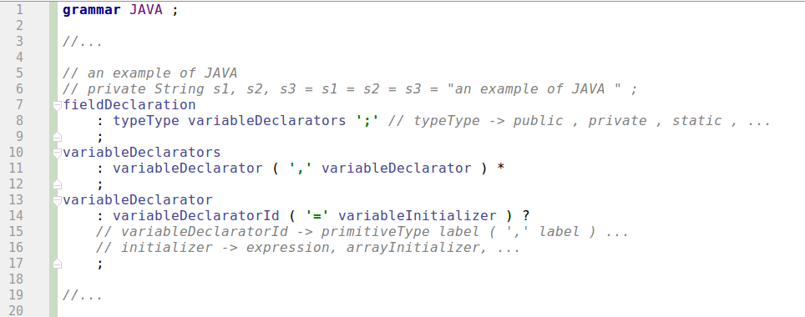
Figure 4.2 JAVA example in DDI pattern

Usually, modern language can be very trick and complicated in some cases, but using DDI pattern makes everything easier and clearer in logics and in physics. The next sections in this chapter is going to introducing RIIF language grammar and RIIF-2 language grammar. They are fully implemented by the pattern DDI. Since RIIF-2 language is the extended version of RIIF language, the RIIF language definition can be useful in designing RIIF-2 grammar process. So, next section will include some definitions of RIIF and RIIF-2 language.

4.2 RIIF-2 Grammar in ANTLR.v4 language

The main feature in RIIF-2 language is the hierarchical organization. It provides a favorable gears for code designer for designing a complex and obscured system. Starting introducing the RIIF-2 grammar from the hierarchical layout can assist in avoiding unnecessary ambiguities, reducing confusions and promoting the understanding in RIIF-2 grammar.

On the basis of the language references, RIIF-2 has two basic modules. One is called template and the other one is named component. From what I can understand, the module “template” is just a special case of “component”. Only with the additional keyword abstract prefixing allows a component becomes a template. Component can achieves some more sophisticated goals with respect to template. Because of this, my offering component grammars will precede my offering template grammars. After having a clearly point of view of component grammar, the grammars for template will be straightforward. Let's dig into the component grammars first.

Figure 2.1 fully displays the hierarchical picture for RIIF-2 language. It tells that a component can extends several components and implements any number of templates. The component grammar definition in ANTLR v4 is :

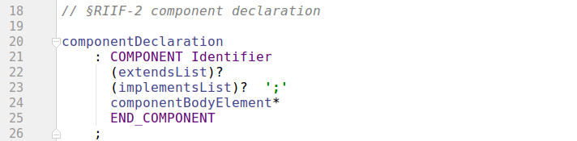
The grammar rule extendsList and grammar rule implementsList are simply a list of identifiers that refer to previous modules and the absence of extended or implemented module is allowed so that the rules extendsList and implementsList are claimed with question mark. The rule componentBodyElements is an all-inclusive grammar which has the possibility to produce any statements that could appear in component.

Figure 2.1 also shows an assignment command set in RIIF-2 specification. A component can gives values to the variables in the extended components through the keyword assign. Moreover, the variables that had declared in the implemented templates with keyword abstract prefixed can be assigned by the component through the keyword set. Together with assignment keyword assign and set, another keyword impose has defined in RIIF-2 language reference but that is used only in templates for providing predefined values.

In addition to that, a component is a coalition which combined of variables which has categorized into four types which are parameter, constant, fail_mode and child_component. From the language references, the form for declaration of parameter and constant is same, they are different in the semantic meaning which is the constant can not be modified once it has been assigned with values while the parameter is a kind of dynamic element that can be assigned with values on demand. For clarify the grammar and reducing redundancies of coding, grammar rules for parameters and constants can be rubbed up into one rule.

Because there is no any constrains in the order of each declaration, that’s just a choice pattern, which we can specify formally with this rule:

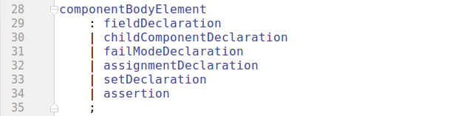
According to DDI grammar pattern, each declaration grammar rule should at least have one grammar rules named declarator. It is easy for defining declarators for child_component and fail_mode, because there has no multiple possibilities for declaring a child_component and fail_modes. For achieving some more comfortable functionalities from code-write's point of view, the grammar is going to be more complicated. Let's take a time to look back the variable definition in documentations.

The documentation says, “ … , the RIIF-2 language includes a new associative array data type, …, the empty brackets are used to denote the associative arrays. In particular they indicate that the number of elements is undefined and new elements can be freely appended to the array..., the extends RIIF language introduces a new date type: table. The definition of a table includes the definition of a header defining the columns of the table data structure and the definition of the table content..., Together with the table data type a new operator denoted with symbol [#] is introduced ...”.

From the above reference, it has confirmed that an associative array structure is a specific structure in RIIF-2 language with the possibility to dynamically assign same type instance-elements in it. Moreover, it has declared that the keyword table is responsible for creating a table structure that performs like a matrix with column labels attached ahead. In practice, there is no in-line initializer for a table structure element and each element can only have one data-structure either a associative array or a table not both. So a good idea is to separate table declarator from the others in order to reducing the intention of implementations.

Data structure List and Array are both convenient structures that has defined in the RIIF-2 language. In order to bring some nice features into RIIF-2 language, we can have announced that List can be defined in two different ways, one is called general list and the other one is named specific list. General list allows code-writer to declare a list structure without specifying its type while specific list can be assigned with a particular type. When the general list is declared, all elements that will assigned to the list will be automatically stored with string or integer. For example there is { item1, “item2”, 20, true } assigned to a list structure. Then the item1 element and the “item2” element and the true element will be recognized to be the type string while the 20 element will be stored with the type integer. Separating the both list in different grammar rules will help to reducing the ambiguities and the amount of codes in implements part.

For associative array data structure, the element can be voluntarily initiated when using the keyword assign assigns a runtime value to the nonexistent element. This is a kind of implicit assignment mechanism. Providing an other way for explicitly initialization an element into a associative structure will completes the associative array data structure. That is the reason why we will see that there is another separated rule for explicit initiation.

From what I have introduced, the keyword set, assign and impose are grammatically similar but semantically different, particularly in the action scope. In order to clarify the grammar, those assignment keywords set should be blended into one grammar rule.

According what we have discussed above, the declaration can be implemented as below.

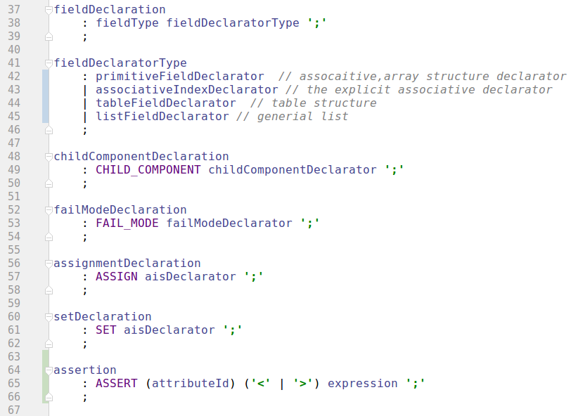
The diagram informs that the fieldDeclration generates fieldType which stands for the keyword parameter and keyword constant. The fieldDecaratorType gives four declarator primitiveFieldDeclarator, associativeIndexDeclarator, tableFieldDeclarator and aisFieldDeclarator, in which the primitiveFieldDeclarator is in charge of declaring a primitive element, the associativeIndexDeclarator is responsible for declarating an instance asset for an already defined associative array. The tableFieldDeclarator and the listFieldDeclarator has the capabilities for asserting a table structured element and a blanking list structured element.

From the definition of DDI, each Declarator should contains a declaratorId and a initializer. In RIIF-2, elements Fail_Mode and Child_Component have not value, in this case, the initializer can be simply omitted. The child_component has an extra part compared to Fail_Mode that is the child_component's type. Considering this, the child component declarator rule should have an extra “small” rule that used to handle the child component type.

In order to increase the readability of the grammar code, the primitive type can be separated from declaratorId and the grammars shows below:

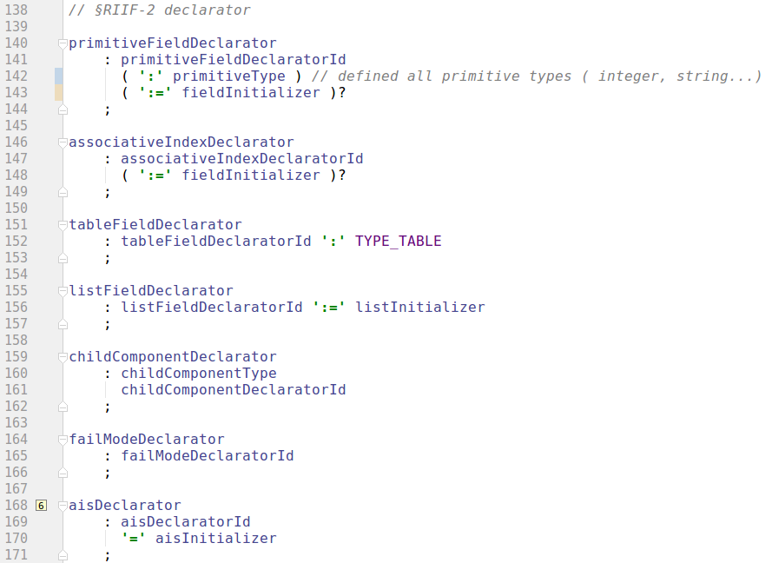
Fig. 15

Thanks to the DDI pattern, all of those declarators look same and easy to understand. This is the benefit of DDI pattern. Of cause, we can not yet finish the job, since the grammar structure is only totally separated into two parts. Dividing questions into sub-sequence questions is always easier, and this point of view can be used into DDI pattern.

Now, stepping down a level of granularity, we get to the grammar rule declaratorIds and the grammar rule initializers. Let's dig into the declaratorId first.

Pursuanting to the language reference, the variables parameter and constant can have a primitive type like integer, string, float, boolean, enum or time. Those primitive type can be comfortably organized into a rule. Although, there was not a evidently definition for whether these variables can be defined to be an user proposed type in the language reference paper, reserving this feature in the grammar is always a good idea in any case.

A field can be defined to be an array if the symbol “[number : number]” is following. The right number inside the array symbol is an expression that refers to the array length while the left number is meaningless now which has to be a constant value 1. A field can also be define to be an associative array if the symbol “[ ]” is following. Since both array and associative array is as a data structure for an element, it is better to represent both array and associative array in one rule.

Each variables have some predefined attributes, and attributes can be assigned with values through the keyword assign in RIIF/RIIF-2 definitions. So the attribute rule should appear in the end of declaratorId.

Since the paramitiveDeclaratorType generates a explicit typed declarator, so we need to separate the associativeIndexDeclarator. The next picture shows the example of RIIF-2 language, and readers can have a clearly idea about the explicit associative declaration.
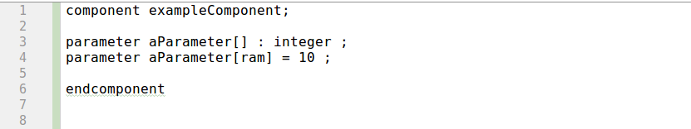
Let's look at the diagram, the line 4 indicates that the explicit element declaration in a associative data structure can be assigned without specifying its type. Because the associative type has been defined before in the line 3. That will not be a problem for failModeDeclaratorId, since fail_mode can no be attached with a type.

The most complicated part would the aisDeclaratorId part, since aisDelcaratorId should conclude everything situations. Let's start to dig into it.

For specifying AisDeclaratorId, let's looking back to the figure 1. A component can extends other components and implements previous templates, and a template can be extended by other templates. Child component has the ability to propagates values to its parents components/templates. This mechanism can makes constructing an extensive and a dependent system more accessible, but also can issues some confusion problems. Lets take the name confusion as an example, if two or more variables exiting in different templates or components have a same name, a component implementing or extending them then can not accurately locate the variable so that can not propagates values to the variable.

Using fully qualified name to address the name confusion problem in the RIIF-2 hierarchical structure can be a good idea. Fully qualified name is a kind of absolutely path that uniquely points to the variables by putting a template's name or a component's name as a prefix. A prefix can follows other prefix till the intended variable. If code-writer does not specifies variable with fully qualified name, the result of parsing is depends on the parser implementation if a name confusion lives. According to the discussion, a rule for expressing fully qualified name should exits. RIIF-2 language has inherited the child component field from RIIF language. Outer component can propagates values into child component elements. Coincidently, the form that used for propagating values into a child component element is so happened to be the same with the fully qualified name addressing form. There has only one exception that is when the child component is declared to be an array or associative array :

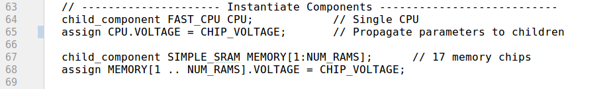
The line 68 in the picture exposes a fact that the fully qualified form has destructed by the array indexing symbol “[1..NUM_RAMS]”. So using one grammar rule to overlap every situations is not physical. Adding another rule named hierPostfix as an optional rule just after array indexing symbol can handle this problem.

Back to the declaratorId, We have discussed that there should have a rule for the definition of array and associative array, following the primitive type. Since the attribute is a typical value that need to be a assigned and almost every variables can have attributes, so a rule stands for attribute is necessary in this case. The last part would be the rule for indicating the sharp operation in table data structure.

Then, the illustrating code is showed below.

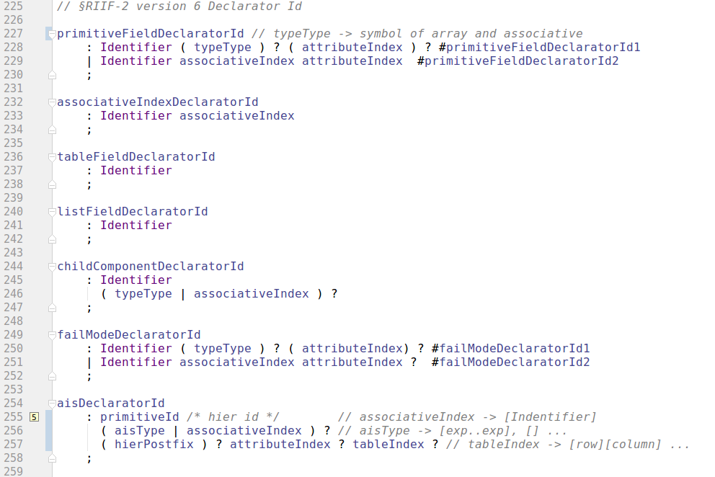

Following the introduction of declaratorId, the next part is the initializer part. In this implementation of RIIF-2 grammar, we have four individual initializers which are listIntializer, arrayInitializer, arrayInitializerWrapper and expression. According to what we have discussed, the four initializers can be generated by the grammar rule fieldInitliazier which has been shown in the figure 15. The fieldInitializer grammar rule is showed:

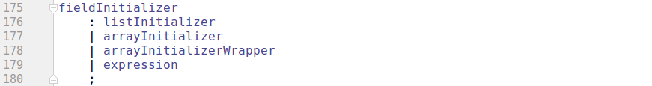
Fig. 16

ListIntializer is in charge of recognizing a kind of list inputs. Each item in the list can be a integer number, a float number, a string or a identifier reference. In current level, the identifier reference is implemented as a string type input.

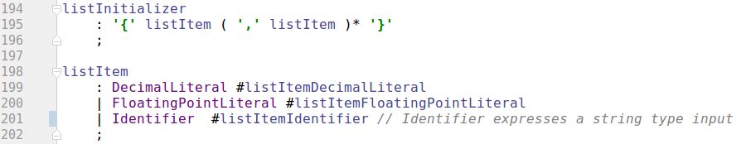
Fig. 17

Expression is indicating expression statements in the RIIF-2 language, and it can represents and distinguishes the mathematical expression or logical expression form from inputs..

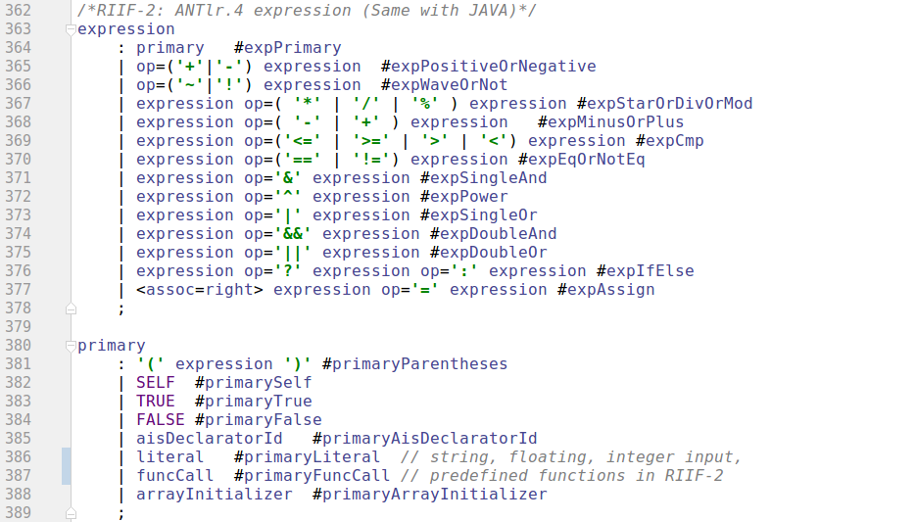
Fig. 18

Normally, expression is a basic grammar rule for most computer language. Introducing expression grammar rule first can benefit building other grammar rules for example the arrayInitializer and the tableItemInitializer that will be introduced later on in this chapter. Let's take a look at ArrayInitializer.

ArrayInitializer is used for representing the array typed initializer. An array element are allowed to be initializer either in-line or through the assignment command set. In this case, the initialization of an array structure looks like :

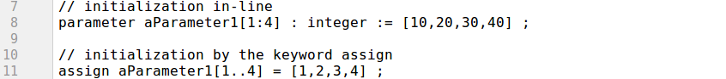
The arrayInitializer grammar rule is as follows:

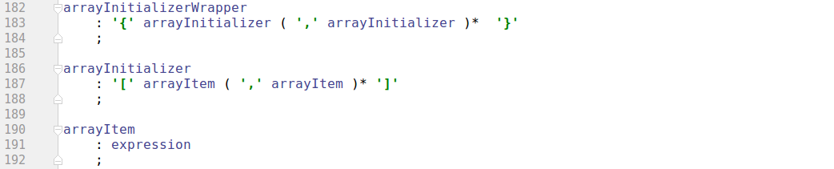
Fig. 19

There is another grammar rule in Figure 19 which is named arrayInitializerWrapper which is used to initialize the table data-structure in RIIF2 language. The table initializer is a JSON-like structure which means that the initializer statements are started by the symbol '{' and ended by the symbol '}'. Each row can be initialized inside the brace separated by comma. In the implementation, there actually has two table data-structure initializer. One is called arrayInitializerWrapper that is used for pure table initializer. Two is called tableItemInitializer that is used for expressing more complex cases table initializer like the initializer in the lines 14~ 18 , 24~27 in figure 6.

The grammar rule tableItemInitialzer is listing in figure 20.

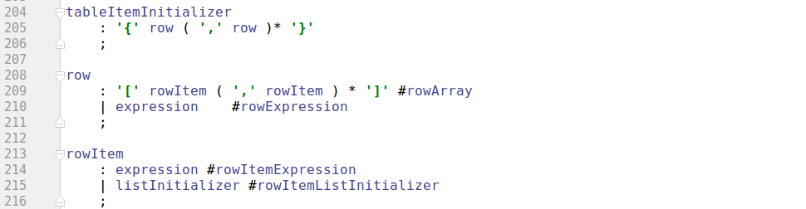
Fig. 20

Now, readers of this thesis report have a full picture about the RIIF-2 grammar, the grammar has been achieved and introduced according to DDI pattern which makes everything clear.

At this moment, the big picture of the RIIF-2 grammar has been introduced and readers of this thesis should have a strong feeling about the DDI pattern and component grammar. The other important modular in RIIF-2 language is the template. Since the modular template is a subset of component and has a similar grammar rules with component, template grammar is a several grammar rule references of the component's grammar rules with the keywords abstract prefixed. There still have other grammar rules which would be introduced while introducing the implemented parser.

Chapter 5

RIIF-2 parser

This chapter is going to describe the implementation of RIIF-2 grammar – the RIIF2- parser. Mainly, this chapter is targeted at hight-level pictures instead of the detailed codes. The parser is implemented in JAVA language and has adopted both visitor and listener mechanisms defined in ANTLR.4. Since RIIF-2 language is focusing on detecting reliability in modern computer systems, then the implementation of the RIIF-2 language has also to be as reliability as possible. Moreover, the implementation of parser can provides some new features into RIIF-2's syntax. For example, the parser that has been achieved in this thesis is a non-case sensitive parser. The parser will convert every user-defined identifiers to lower case, which may raises the reliability of RIIF2. Let's image a 50MB RIIF-2 file, a case-sensitive parser will be leading the code-writers or the code-readers into a bad intension in which the users must remember the every letters' case.

5.1 Implementations of Visitors and Listeners Pattern

Visitor mechanism has been introduced in this thesis in chapter 3, which is a kind of parser tree worker in ANTLR.v4 and has the possibilities to let users to control the walk by explicitly calling methods to visit children. Since component and template are defined as two individual modules in the RIIF-2 language references and the RIIF-2 language still need to be developed, consider scalability, it is better to create two parsers one for template and the other one for component.

The achieved parser allows users to write RIIF-2 modulars in one files or in different .RIIF2 files. Normally, the more flexibility it performs, the more situations it have to be considered. If the parser allows user to combines dependency modulars into one files, then the parser has to figure out a way to separate each modular in order creating appropriate parser for each modulars. Fortunately, the ANTLR .v4 runtime automatically creates parser tree based on a valid inputs and the visitor mechanism plays the role, separator, who has the ability to automatically recognize each grammar nodes in the parser tree and feeds off a corresponding method callback.

The class named SLV (Second Level Visitor) is the implementation of visitor mechanism in ANTLR.v4 and it is in charge of recognizing the second level nodes in the parse tree. The second level grammar nodes is as following:

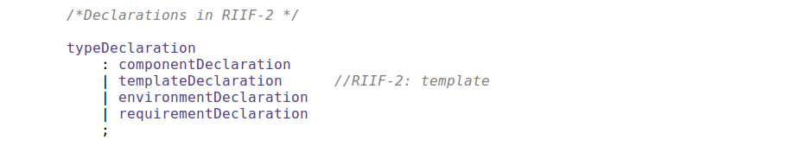
Fig. 21

From the figure 21, the second level nodes in the parser tree are componentDeclaration, tempalteDeclaration, environmentDeclaration and requirementDeclaration. ANTLR.v4 can automatically generates visitors callback methods and they are hugged back to the parser tree. Once the ANTLR runtime walker found a grammar rule, it will fire off the RuleContext object which is a context object includes every information about the rule into the callback method. By extending the RIIF2BaseVisitor, SLV class gains the capabilities to manage the built-in walker in the parser tree.

The class SLV is implemented as following:

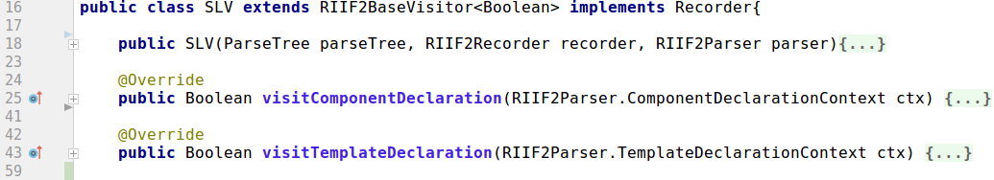
Fig. 22

In this way, the ANTLR.v4 visitor will calls method visitorComponentDeclaration(...) when it found a componentDeclaration grammar rule and calls method visitorTemplateDeclaration(...) when it found a templateDeclaration as well. By creating a component parser in the method componentDeclaration and creating a template parser in the method templateDeclaration, we can parsing components differ from parsing template. In this situation, the next-step designer can simply modify the template parser without inflecting the component parser when the RIIF-2 language will be further exploited.

Component parser and template parser are constructed thorough the listener mechanism that has been provided in ANTLR.v4. By extending RIIF2BaseListener, the componentParser and templateParser can be created and recognized each grammar rule that has define for RIIF-2 language in chapter 4 along with the built-in parse tree walker.

The figure 23 below is the logic picture in UML that has been adopted.
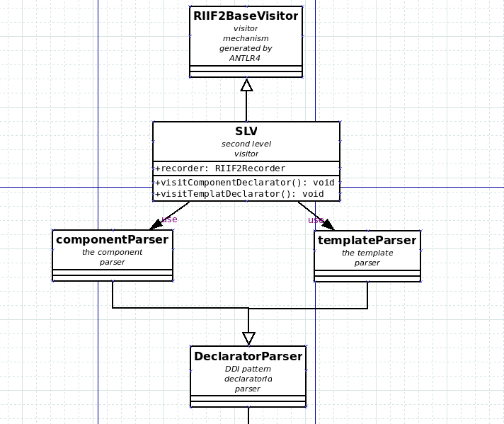

Fig. 23

The DeclaratorParser is the last implementation class of the Listener mechanism. The others will be introducing in next section.

There is an important field in SLV class in figure 23 called RIIF2 recorder. RIIF2Recorder is actually a “bond” that links dependent modulars and has the responsibility to records every information that appear in RIIF-2 definition file. The details of RIIF2 recorder would be introduced in details in section 5.3.

5.2 Hierarchy of the Parser

The figure 23 shows that the parser is made of two parsers, componentParser and templateParser. In current level, both parsers are implemented in same hierarchical structure. So let's introduce the componentParser as an example.

In order to parse the input RIIF-2 definition files, we have to almost implements all the callback methods that have appeared in the class RIIF2BaseListener. For reducing the ambiguities and promoting the readability and re-usability, it is better to divide the implementations into several JAVA class. For this RIIF-2 parser, those callback methods has been implemented into 7 individual classes. The UML diagram is attached below.

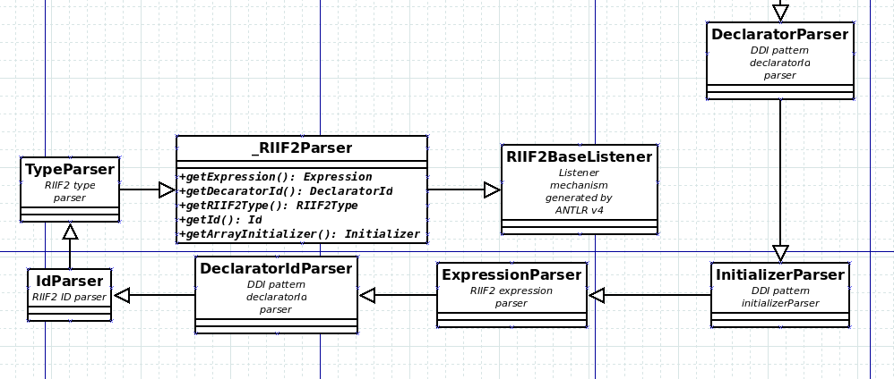
Fig. 24

Each parser class is only in charge of one thing. For example the typeParser class is only used for processing the types that may appeared in RIIF-2 language like primitiveType: integer, string, float… and the date-structure types like: array, associative array and enumeration. IdParse has the responsibility for processing the appeared Id rules in the RIIF-2 grammar like: attribtueId, associativeId, tableId... DeclaratorIdParser, InitializerParser and DeclaratorParser are those parsers that implements DDI pattern. In fact, the expressionParser is also belongs to initializers in DDI pattern, but the implementation codes is too big and the expression is normally a basic grammar rule that is being used by other initilaizers. Because of this, it is better to complete expression grammar rule in one class and let other initializers extends the expression class and use it.

Figure 24 is also indicating that a class named _RIIF2Parser appears and precedes every parser class that provides 5 abstract methods: getExpression(...), getDeclaratorId(...), getRIIF2Typy(...), getId(...) and getArrayInitializer(). The class _RIIF2Paser is a tricky class normally used by parent parser classes to hook the child parser classes up. It is healing I called “a generation problem” in JAVA world. Let's take the abstract method getArrayInitializer() as an example, the figure 18 discloses a fact that an arrayInitializer is the one of the productions of grammar rule primary which shrink back to a expression. According to the theory of bottom-up parsing strategy in formal language, the arrayInitializer has to be executed before the execution of grammar rule expression. But the figure 24 tells that the arrayInitilizer is implemented inside class initializers who's hierarchical level is below the ExpressionParser class. In this case, ExpressionParser class is the parent of initializerParser class. In JAVA world, a parent class is not allowed to invoke its children's method, which make an irreparable trench in the logic. Re-organizing the listener hierarchical level by putting the initializeParser class before the ExpressionParser is unphysical and will cases more problems, not only because expression is a basic grammar rules that will be used everywhere in initializers but also breaks down the grammar logic. Thanks to the abstract class mechanism in JAVA world, ExpressionInitializer can hook the children's method back to parent by using the abstract method getArrayInitializer.

The usage of the “hook” is as following:

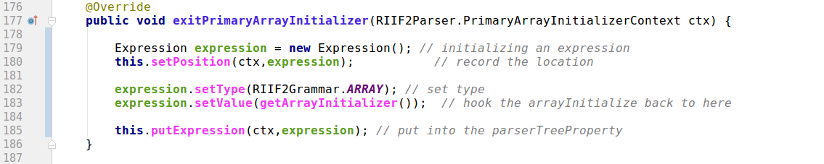

A challenge during the implementation of RIIF2 parser is how to implement the expression grammar in RIIF2 grammar in a proper way. Figure 18 has listed the expression grammar. Apparently, the expression rule is a recursive grammar rule, because expression products can be shrank back to expression rule. Since the expression grammar rule is recursive, then it would be a good idea if we can organize the same recursive structure in classes in JAVA world. In order to figure out the organization of classes, we need to survey the structure of parse tree and the behavior of ANTLR v4 walker.

According to chapter 3, the introduction of ANTLR.v4, the ANTLR walker is a kind of deep-first visitor. It will call the node listener method enter...() while it starting visit the node and it will call the listener method exit...() while it starting leave the node if we adopt the listener mechanism in ANTLR.v4. In this case, each exit...() listener method should have full knowledges of the children expression.

Let's start looking an simple mathematical expression example: 1 + 2 * 3 + 4. The priority of multiplication is higher than addition according the mathematical rule. ANTLR will automatically handle this for us if we put the multiplication expression before putting the addition expression in expression grammar rule as the figure 18 showed. Figure 25 expressed the parse tree that ANTLR has automatically built. From the diagram, we can observe that ANTLR will consider the multiplication expression (expStarOrDivOrMod) first before addition expression (expMinusOrPlus). In this situation, we can compute the result of multiplication in listener method exitExcStarOrDivOrMod(...), after that, compute the result of addition in listener method exitExpMinsOrPluc(...).

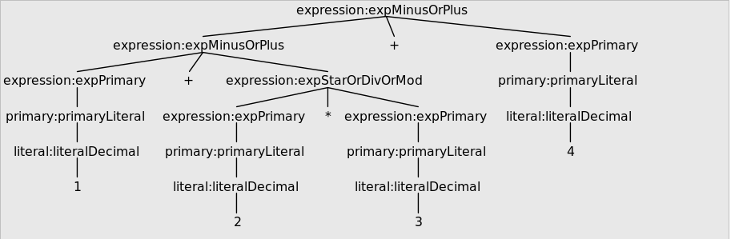
Fig. 25

Now lets consider the grammar rule of expression, since the grammar rule have to coincide with the way that we have described before. Let's consider the next example that could be occurred in RIIF2 language. Figure 26 in the following has showed the example: “parameter ram2 : float := ram1 + 10 * contantRate; ” in RIIF2 language, which is normal case in modern language using variable names as references and operating the values that has stored in the references.

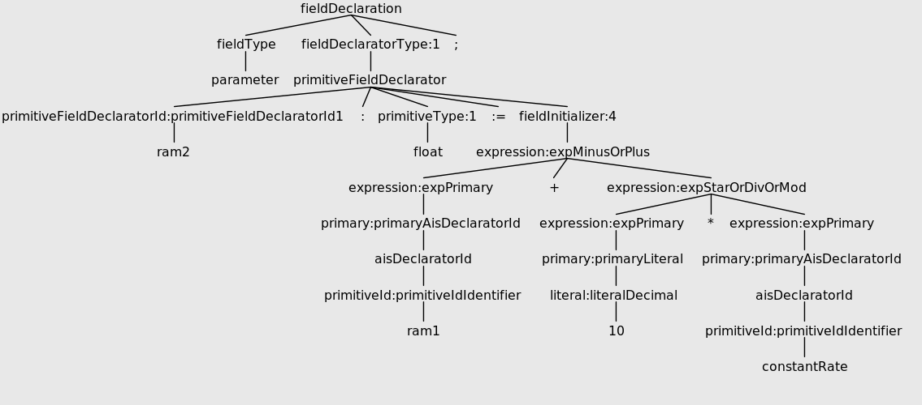
Fig. 26

There is a reference ram1 in the the expression. If we want compute the result of the multiplication expression, we have to access to the variable constantRate and retrieve the value it got. It is not a good idea to access the variable during the parser for such a huge language, because the parser structure is hierarchical and it would be really complicated and would cases some confusions (from the code reader point of view). Instead of accessing the variables in all the hierarchical parser structure, it is much better to access variables in one “point”, in this way, the code organization is will be clear and shapely. The best in a hierarchical structure for this job is the relative root node. For component parser, I choose grammar rule componentBodyElement as the relative root and all parsed data are structured into corresponding class and aggregated into class ComponentFactory who is in charge of checking the correctness of those data and store the checked data into Recorder class.

Figure 27 has expressed the expression structure in UML, from which we gain that there has two classes one is called operation and the other one is called Expression. On one hand, class Operations are aggregated into Expression class in the field operationQue with a type Queue<Operation> thorough the method putOperation(...). On the other hand, class Operation handles two expression they are named oprExpression and targetExpression.

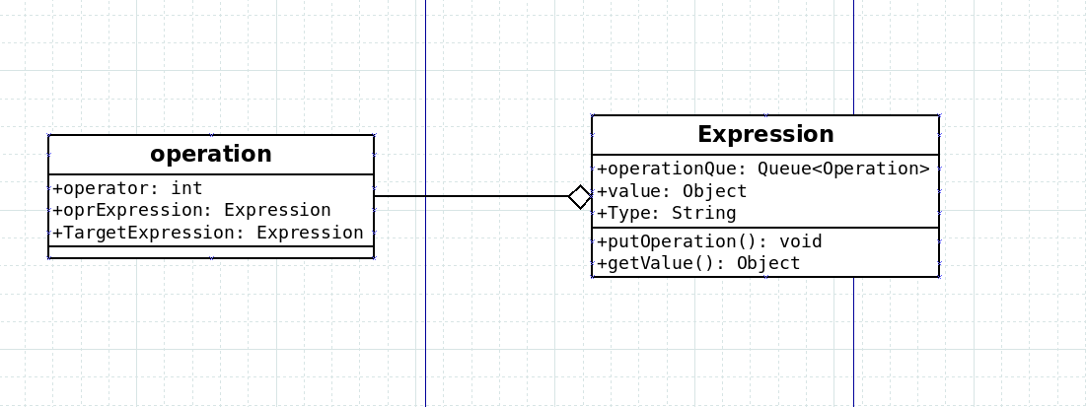
Fig. 27

For clarifying the description of the expression structure, figure 28 shows an example of the procession of generating expression structure.

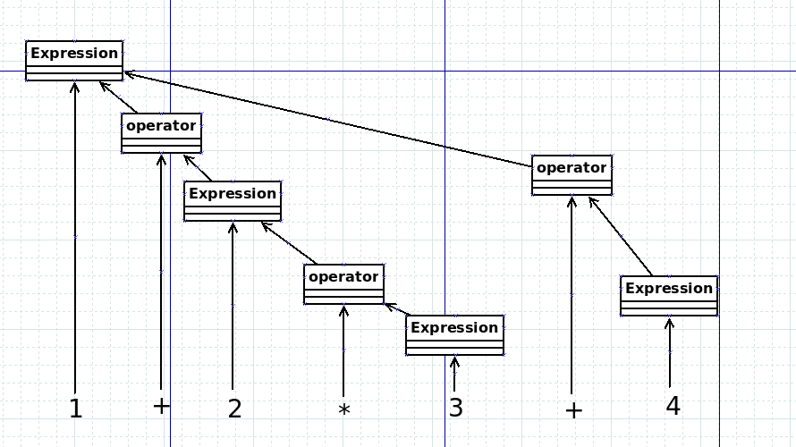
Fig. 28

Do not confusing figure 28 with parse tree, it is a structure of expression with the 1 + 2 * 3 + 4 inputs. Each expression grammar is expressed in an expression class like the multiplication expression 2*3 in the example. Each expression can be stored into an Operator class when the expression has to be generated to another expression recursively. In this way, only one Expression class exists after no matter how complicated mathematical expression and logical expression. When we have to access the Expression class, we should use recursive method. Let's take the final Expression in figure 28 as an example, after parsing the mathematical expression we can get an Expression object which contains the value 1, the type Integer and two Operation class in its Queue data structure. The first Operator object contains a “+” operator and another expression which stands for the result of expression 2 * 3. For getting the result of 2 * 3 ,we have to pop the second Operator object from the second Expression and gets to know the operator '*' and the third expression 3. By calling the recursive method getValue() in the first Expression Object, it will recursively get each expression value. In this way, we can have the final value, if there have an expression not suitable for the expression (like an invalid expression 1 * true ) it will raise an exception and notice the user that there has a illegal expression.

Factory Mechanism

This section is going to introduce the Factory Mechanism that has been used in the parser. Basically, we have a abstract Factory class with an abstract method commit it is be extended by other four concrete Factory class with the corresponding implementation of commit() method, there are FieldFactory, FMFactory, CCFactory and AisFactory.

According to what we have discussed above, we collect all informations and constructs serveral proper objects for each componentElement grammar rule for each inputs, then passes them into class ComponentFactroy and calls commit() method in ComponentFactor object from exitComponentElements(...) listener method. In each componentElement

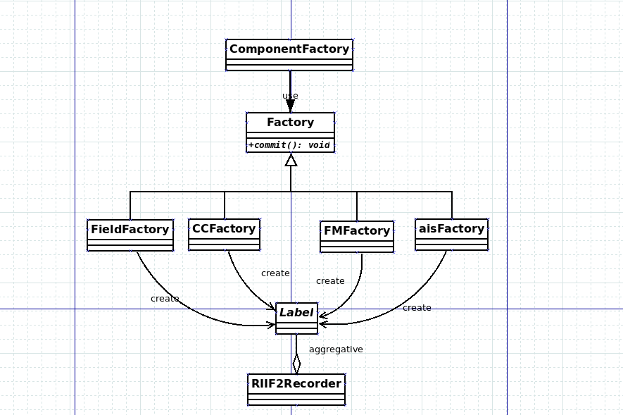
Fig. 29

